

Assignme



Comsats Institute Of

Information Technology

Islamabad

**MCS 3 (Operating System)**

**Assingnment #3**

|  |  |
| --- | --- |
| Name | Imran Abbas |
| Registration No. # | Sp18-mcs-017 |
| Class | MCS-3 |
| Subject | SE-2 |
| Submitted To |  |
| Date | 26/04/2019 |

Git Hub Commands

Config command:

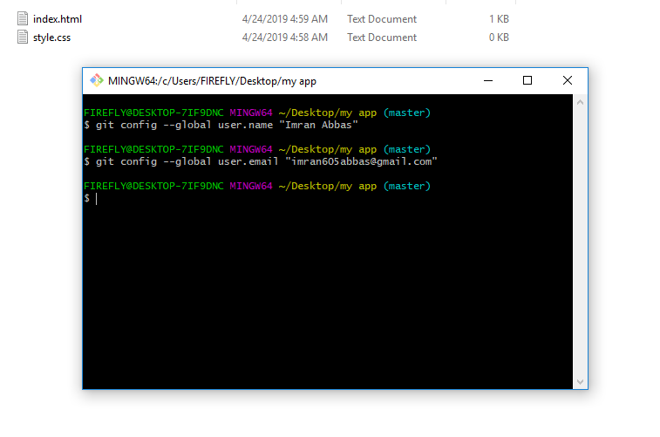

Init command:

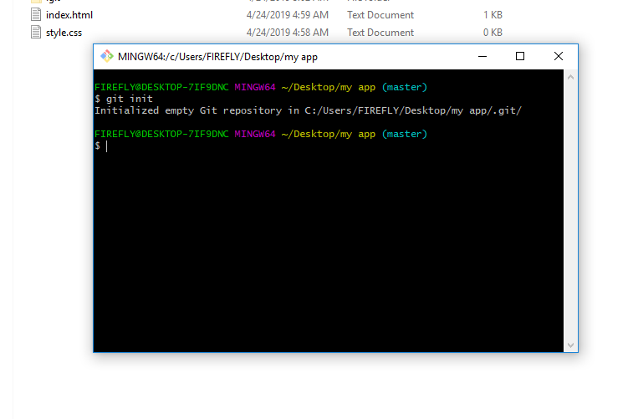

Status command:

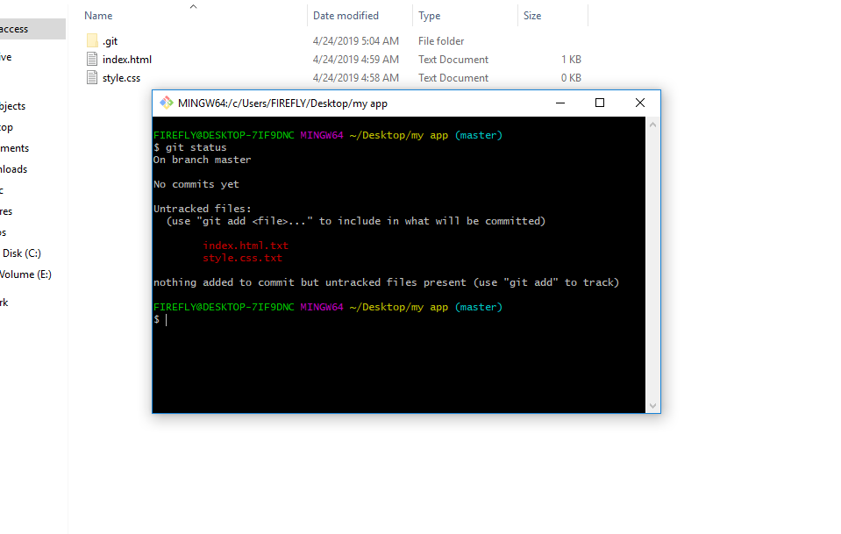

Add command:

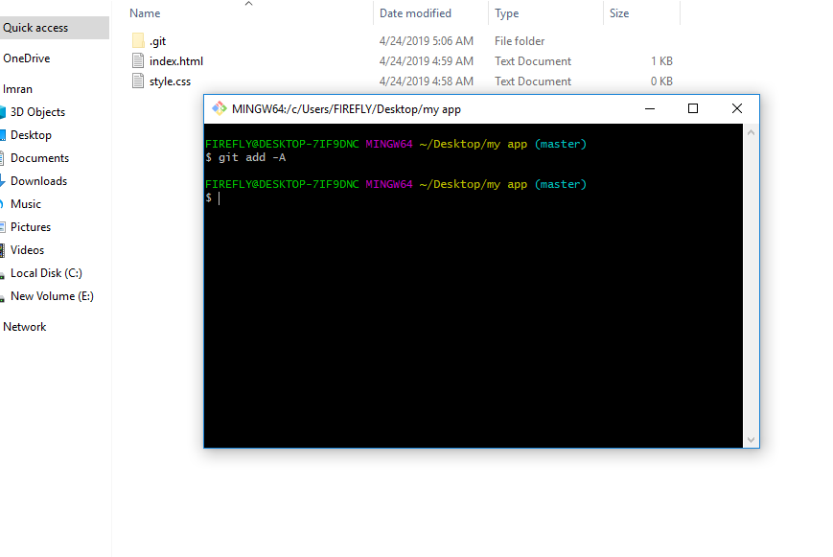Commit command:

